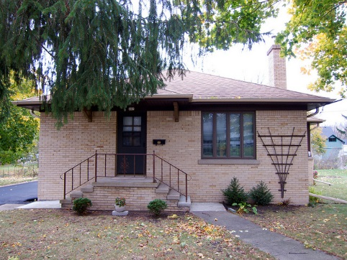
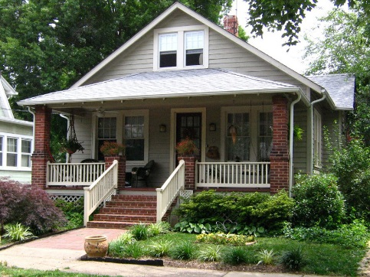
2020 Vision

Healthy Homes and Sustainable Communities

Data Report 2017

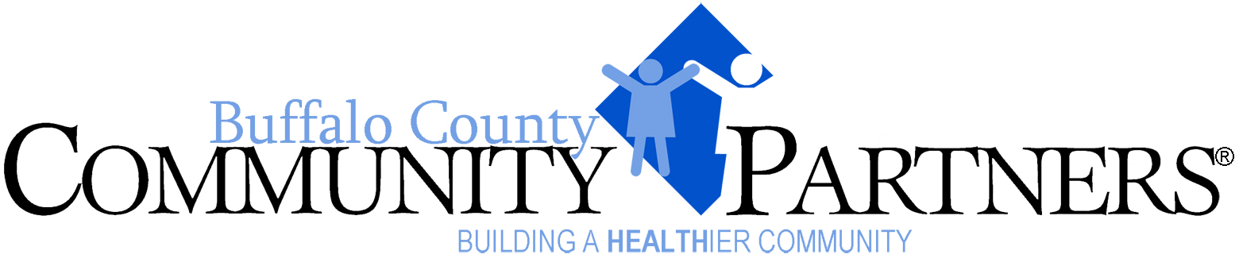

Healthy Homes and Sustainable Communities

Data Report 2017

Introduction

Buffalo County Community Partners has developed a 2020 vision around five strategic directions:

- Active Lifestyle and Healthy Eating
- Eliminate Health Disparities
- High Impact Prevention Services
- Healthy Homes and Sustainable Communities
- Injury Free Living

Each strategic direction has identified 2020 well-being indicators as well as measures and targets. The purpose of the data reports for each of the strategic directions is to provide baseline and indicator data directly related to each of the strategic directions to measure and review changes in the community data. Data sources are indicated within each of the tables and figures. The tables and figures may include, when available and appropriate, regional, and state data comparisons.

2020 Well Being Measures

The 2020 well-being measures (and objectives) for “Healthy Homes and Sustainable Communities” are listed below.

- Increase the number of homeowners in the community
- Increase the number of affordable housing units in the community

Data on the first of these two measures is included (see Figure 3), whereas the latter is currently unable to be obtained. This report contains housing and poverty data from the U.S. Census Bureau, with one item from the Buffalo County Behavioral Risk Factors Survey.

Housing Data

The total number of housing units in Buffalo County has risen steadily from 2000 to 2015 (Figure 1).

(U.S. Census & American Community Survey)

According to the U.S. Census, the percentage of housing units that are occupied in Buffalo County was higher than the state in 2000 and has continued this trend from 2007 to 2015. As of 2015, an estimated 94.0% of housing units in Buffalo County were estimated to be occupied (compared to 91.0% for the state) (Figure 2).

(U.S. Census & American Community Survey)

The total number of owner-occupied homes in Buffalo County declined from 2007 to 2009 but has been gradually trending upwards since then to an estimated 11,617 owner-occupied homes in 2015 (Figure 3).

(U.S. Census & American Community Survey)

Although the percentage of occupied housing units in Buffalo County has been consistently higher than the state (see Figure 2 above), the percentage of occupied housing units that are owner-occupied in Buffalo County has been consistently lower than the state, thus indicating that a higher percentage of Buffalo County residents are renters. As of 2015, an estimated 63.3% of occupied housing units in Buffalo County were occupied by owners (compared to 66.2% for the state) (Figure 4).

(U.S. Census & American Community Survey)

The median housing value has risen steadily for both Buffalo County and the entire state from 2000 to 2015. The median housing value in Buffalo County has been consistently higher than in the state as a whole. There has been a considerable increase in median housing value in Buffalo County in more recent years. As of 2015, the estimated median housing value in Buffalo County was $151,300 (compared to $133,200 for the state) (Figure 5).

(U.S. Census & American Community Survey)

Although the median housing value in Buffalo County has been consistently higher than the state as a whole (see Figure 5 above), the average monthly cost of owning a home has been largely comparable between Buffalo County and Nebraska (Figure 6).

(U.S. Census & American Community Survey)

The median cost of rent in Buffalo County is comparable to the state. As of 2015, the U.S. Census estimates the median cost of rent in Buffalo County to be $722 (compared to $726 for the state) (Figure 7).

(U.S. Census & American Community Survey)

In Buffalo County, an estimated 17.1% of all housing units have been built after 2000, compared to 14.2% for the state, indicating moderate growth in new development in Buffalo County (Figure 8).

(U.S. Census & American Community Survey 3 Year Estimates)

Poverty Data

The percentage of the population in poverty in Buffalo County has a slight declining trend since 2009 according to Census estimates, while poverty in the state continues to trend slightly upward overall. As of 2015, 13.1% of the population in Buffalo County was in poverty (compared to 12.7% for the state) (Figure 9).

(U.S. Census & American Community Survey)

In the 2016 Behavioral Risk Factors Survey, 21.2% of Buffalo County respondents reported that they were always, usually, or sometimes worried about having enough money to pay their rent or mortgage (Figure 10).

*Those reporting that they were always, usually, or sometimes worried or stressed about having enough money to pay their rent or mortgage.
°Includes Buffalo, Dawson, Gosper, Phelps, Kearney, Harlan, and Franklin Counties.
(Source: Behavioral Risk Factors Surveillance System)

